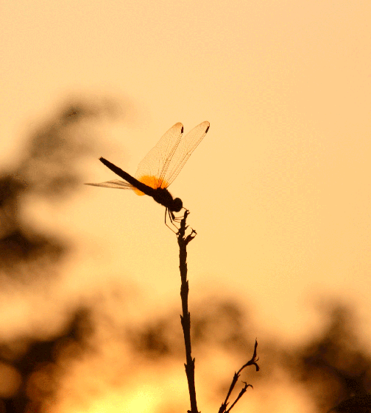

Student Workbook

What’s Buggin’ You?
Let’s Fix It.

We want to hear your realistic
solution to a local environmental concern.

You can make it happen.
We can help.

This workbook belongs to:
www.CaringForOurWatersheds.com
Name:
School/Club:
Grade:
Date:

Call to Action

Take a look around you and think of how you can help protect and improve our water, air and land.

Pick one concern and come up with one idea to help fix it.

You can make a difference and have a chance to win prizes for yourself and your school or registered not-for-profit club (such as 4H or FFA).

Implementation funding is also available.

What is a watershed?
A watershed is all of the land that drains to the same location or body of water. People tend to think only of water bodies such as rivers, lakes and wetlands as being part of their watershed. However any upland whether it be a park, field, or even a parking lot, is also included.

Watersheds know no borders, whether national or international and are key to a healthy environment.
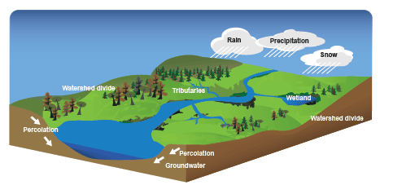
Why are watersheds important?
First and foremost, people and animals rely on surface water (streams, lakes, rivers) and groundwater (water stored underground) for drinking as well as for growing and processing food, creating energy, and manufacturing products. The actions we take on the land can impact the quality and quantity of our water supply. Our local actions not only impact our own environment, economy and society but also our neighbors around the world. Remember, we all live downstream from someone else.

Your Watershed Facts
NOTE: This is for your learning. Only include details relevant to your solution in proposals.

What watershed do you live in?

How big is your watershed?

How many people live in it?

What are the main sources of water? i.e.) rivers, lakes, aquifers, rainwater, glaciers

What are the names of the major bodies of water?

Describe the land i.e.) Desert, rocky, mountains, prairies, hills, forests, swamps, wetlands

What are the largest towns/cities?

Does your watershed cross provincial/state/national borders? If so, what borders?

Where does the water in your watershed come from? Where does it flow to?

What are some of the main businesses in your watershed? ie) Agriculture, Manufacturing, Oil & Gas, Recreation, Tourism

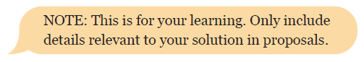
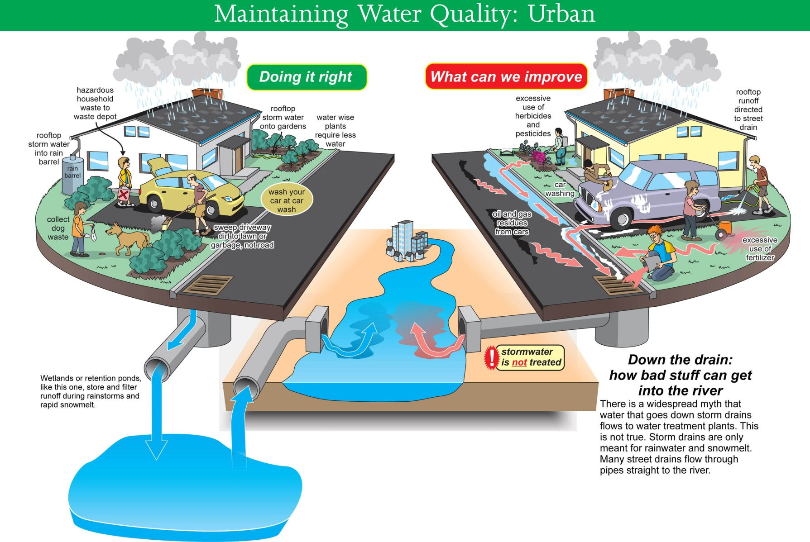
Maintaining Water Quality: Urban

Make a list of:
What we are doing right
What we can improve
Doing It Right
What are some of the opportunities to improve your watershed?
Land/ Water Quantity Land/ Water/Air Quality

Describe some good things you see people doing to help the environment in your watershed i.e.) Schools recycling paper, community gardens, battery recycling program, highway garbage pick-ups…

How do these things help the watershed either in Quantity or Quality?
Describe the good things you see people doing to help the environment in other watersheds.
True or False
T F 1. Roots of plants provide the glue that holds streambanks and shorelines together and prevents erosion.

T F 2. In healthy riparian areas you would find trees and shrubs that are all the same age.

T F 3. A meander is a bend in the river.

Check your answers on the next page.
Doing It Wrong
What are some of the issues or concerns in your watershed?
Land/ Water Quantity Land/ Water/Air Quality

Describe some of the concerns you have
i.e.) car oil washed down storm drains, litter on streets, decreasing green grass areas, 20 minute showers…

How are these things harming the watershed either in Quantity or Quality?
One Concern:
From the list above, LIST ONE CONCERN you would like to focus on.
One Solution
Identify a realistic solution to address the concern you circled using the following guide:

Think of something INNOVATIVE that you could accomplish in your watershed, or a concept that exists, but could be done better.

Briefly describe your solution:

Is your solution…CREATIVE and ACHIEVABLE?
How so?
What
My idea involves…
Recreation
Agriculture
Manufacturing
Transportation
Education
Other
Describe what stakeholders above you are trying to help:
Where
My idea will start in…
My Backyard
School
Community
Province/State
Country
Other
Describe where your idea will take place:
True False Answers
1. T, 2-F (all ages of trees and shrubs are found in a healthy riparian area), 3. T
When
My idea will occur…
Right away Next year Other
Make a timeline for when things will occur:
Month | Task

Who
My idea will need help from…
Family/Friends School/Club Community Members Industry Expert
Government Other
Make a list of people who you will need to contact:
Why
My idea will help the…
Land Air Water Other
Describe why this idea will help the watershed:

Budget
How much will it cost? Where will you get the money?
A budget describes where the money is being spent (Expenses) and where you are getting it from (Income/Revenue).

A detailed budget must include everything that you will be spending money on. Some important considerations are things like paper, hardware (like toilets, taps), installation, volunteers, etc.

Some items or services may be donated. They may include things like Mr. X from the school will be installing the toilets and so while you are NOT paying him directly, someone else is, or he is volunteering his time. The $ amount that you would have had to pay him can be considered in-kind. If people or an organization gives you materials, that too is considered in-kind. For example, maybe your school will be providing the paper and photocopying for your project. You will have to research how much that paper is costing the school to include it in your budget.

EXAMPLE Budget
Item | Amount per item | # items | Total Project Cost | Income/  Revenue  Donated | Total Cash Still Needed
Poster paper | $1.00 per sheet | 50 | $50 | $0 | $50
Photocopying | $0.10 per sheet | 50 | $5 | $5 | $0
Toilets | $200 | 10 | $2000 | $0 | $2000
Installation Time | $30/hr | 20 | $600 | $600 | $0
Total |  |  | $2655 | $605 | $2050
This is the total cost of the entire project
This is the amount that is being donated from all sources (cash, in-kind items or services, unconfirmed requests, etc.).
This is how much actual cash you still need to complete your project.

Remember, you cannot spend money you do not have! If there is still cash needed in your budget, be sure to explain where the funds will come from.

YOUR Budget
Item | Amount per item | # items | Total Project Cost | Total Donated | Total Cash Needed
Total

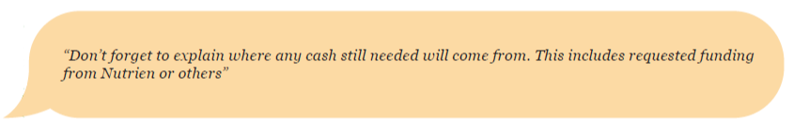
Creativity
Community judges will be reading your proposal and they like visuals. Visuals can often sell your idea better than words.
If your idea involves a brochure, poster, video, song, cartoon, book or model – then make it and attach it to the essay.
If your idea doesn’t have a tangible visual then include diagrams, charts, graphs and tables to showcase your facts.
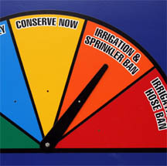
References
Do you know what plagiarism is? If you answered, yes, then don’t do it! You’ll be disqualified from the Caring for our Watersheds contest. If you’re not sure, think of it this way. If you copy and paste content from someone else you have to say who wrote it, when and where. All research that has been quoted, paraphrased or summarized must have proper in-text citations (such as MLA or APA guidelines:
http://bcs.bedfordstmartins.com/resdoc5e/RES5e_ch09_s1-0001.html).
Improper Quote
Water is the most important thing to life on this planet without water there is no life. That is why I want to focus my proposal on protecting this most important resource. I think that you can only live without water for like three or 4 days.
No research or expert has been quoted.

Proper Quote
Example 1:
On the Environment Canada website it states that 30% of the water used in the home is flushed down the toilet (Environment Canada, 2001, Water Use. Referenced from:
http://www.ec.gc.ca/Water/en/manage/use/e_use.htm)
Example 2:
Bruulsema (2012) said, “4R Nutrient Stewardship is...simple – apply the right source of nutrient, at the right rate, at the right time, and in the right place” (p. 2).
List of References:
Bruulsema, T. (2012). 4R plant nutrition. Washington, DC: Simon & Schuster.

Can YOU make this project happen
with the people/time line/budget you’ve proposed?

Congratulations! You’re nearly ready to enter to win $1,000!
Caring for our Watersheds Contest
Caring for our Watersheds is an international competition that combines the passion from industry, conservation and education into an award winning program for YOU. CFW is a contest which is hosted in watersheds around the world - enter the contest closest to you.
By telling community judges your solution you have a chance to win rewards for yourself, your school/club and your idea!
Use the information you have compiled in your Student Workbook to write a 1,000 word proposal. Remember, this isn’t an essay on what a watershed is - this is a proposal to the community on ONE solution that you have that would make an actual difference to the watershed. Think your idea through as if you were actually going to do it… and afterwards… we just might fund it!
Prizes
First place is $1,000 cash to you and $1,000 to your school or club.
$10,000 is also up for grabs to turn ideas into reality.
SMART Proposal Writing
When you are writing your proposal, ask yourself “is it S.M.A.R.T?’
S – Specific Is your plan detailed? Try to keep it from being too broad or general. Talk about what ONE SOLUTION and the actions you are going to take to make it happen.
M – Measurable Set clear goals for yourself. What do you want your project to do? Make your goals specific so you can evaluate whether you are successful.
A– Achievable Make your project achievable. If you need help making your idea happen, make sure you identify who needs to be involved (government, industry organizations, conservation groups etc).
R – Realistic Is it possible to complete this project? This project could really happen and the more reasonable it is, the more likely it is to succeed.
T – Timely How long would it take? When would you complete your project by?
The Proposal
- Introduction (1 paragraph) ☐
- Define your watershed
(1 paragraph) ☐
- Identify your concern
(1 paragraph) ☐
- Explain your solution (3-4 paragraphs) ☐
- Explain the scope of your project (3-7 paragraphs) ☐
- How will this benefit the environment? (2 paragraphs) ☐
- Explain the resources needed (2 paragraphs) ☐
- Conclusion (1 paragraph) ☐
- Include visuals ☐
- Cite references ☐

Note: paragraphs listed are suggested lengths. Your proposal does not have to match this exactly.
HINT: Print this page and check off items as you write to make sure you have all the information you need in your proposal.
The Proposal - A Detailed Overview
1. Introduction
This is your chance to catch our attention and tell us what you are going to talk about in your proposal. Make us care about your project by thinking about why it is important to you. Remember, this is YOUR water and YOUR watershed.
2. Define your watershed (Page 3)
Tell us what watershed you live in. Keep this section brief. Remember this is not an essay on the state of your watershed but a proposed SOLUTION to a concern in the watershed.
3. Identify the issue or concern you want to look at (Page 6)
Pick one specific issue that you see in your watershed. Then, tell us about that issue: what is causing it, what impact do you see in the watershed (for example: is water quality decreasing), and why you think this issue is important to do something about it.
4. Explain your solution (Page 7)
What can you do to improve your watershed? Within your school, your home, or your community, what is something you can do to help your watershed? You could educate people, monitor water quality, or create a piece of art; anything that you think could have a positive impact on your watershed. Be specific about what you will do, how it will work, and what it will take to make it happen. Be realistic!
5. Explain the scope of your project (Page 8)
The scope means: how big of a project this is and how far the effects will go. Is this a local project that will affect your home, your school, your county, or even your province? Is this project something that you can do alone, or will you need help? How many people will be affected by this? Think about scope in terms of the amount of work you need to put in, the number of people it affects, and the amount of area it will cover.
6. How will this benefit the environment? (Page 8)
Explain to us how your idea is going to make positive changes to the environment. Maybe you plant to educate people so they change how they do things. Maybe you’ll bring awareness to an issue that people know nothing about. Maybe you will make people see your watershed in a whole new way. Tell us why this is going to work! Remember, you are “selling” this idea to us.
7. Describe the resources needed to make this idea happen (budget) (Page 12)
You should be able to implement this project, so what will you need to make it happen. What will it cost and where will you get the funding to pay for it? Tell us where and how you will make this project happen. Think about materials needed, the costs involved, as well as the time required to make this project happen.
8. Conclusion
Sum up your idea and why it will help your watershed. Remember, don’t introduce anything new about your idea, just go over what you’ve told us to remind us how great your idea is.
9. Include visuals
Show us what your idea would look like in a model, drawing, cartoon, video or graph – whatever creative way you want to express your solution. For example, if you want to make a watershed awareness brochure – write and illustrate a brochure! If you want to plant a native garden – draw us a picture or make a magazine collage of the plants you would include, the size it would be, where it would be located etc.
10. Cite References
Community judges will be reading your proposal and they are often conservation experts, so it is important that you cite your references. Who knows …you might be citing some of their research!

Judge’s Scoring Rubrics
This is what the judges will be using to mark your completed proposal.
INNOVATION
Minimal |  | Adequate |  | Impressive
0 | 1 | 2 | 3 | 4 | 5 | Value
• Identifies a minor local issue with existing techniques in a common application. |  | • Identifies an important local  environmental issue.  • Uses existing techniques in a new  application |  | • Identifies a substantial environmental issue: local, national or international.  • Uses a new approach or an existing technique in a highly creative manner.
ENVIRONMENTAL POTENTIAL
0 | 2 | 4 | 6 | 8 | 10 | Value
• Solution has little or no environmen- tal improvement |  | • Solution has positive environmental improvement but may be difficult to repeat in other places of the water- shed. |  | • Solution could result in a clear envi- ronmental improvement and could easily be repeated in other places in the watershed.
COMPREHENSIVE SCOPE AND COMMUNICATION
0 | 2 | 4 | 6 | 8 | 10 | Value
• Common knowledge has been applied. The proposal presents a basic understanding of the problem and its solution.  • No clear introduction or conclusion  • No references provided; may have copied a single source. Little research |  | • The project has an adequate degree  of vision and complexity.  • Has an introduction, body, and conclusion but flow between ideas is weak  • Several sources provided. Some  research |  | • The project thoroughly reflects a deep understanding of the issue, its solution, and complexity.  • Introduction, body and conclusion are captivating, flow smoothly and are well-balanced  • Many sources cited throughout proposal. Extensive research
BUDGET
0 | 1 | 2 | 3 | 4 | 5 | Value
• No costs of project have been men- tioned or values mentioned appear unrealistic. |  | • Costs of the project have been ana- lyzed. Values appear accurate but a few costs may be missing. |  | • A detailed budget has been included. Values appear accurate and all en- compassing.
REALISTIC SOLUTION
0 | 2 | 4 | 6 | 8 | 10 | Value
• Project may not adhere to existing  laws.  • This project is unlikely to be  implemented.  • No steps have been taken to  show how it could be implemented. |  | • Project complies with existing laws.  • This project is likely to happen at the  local level.  • Some steps have been taken to  show how it could be implemented. |  | • Project complies with existing laws and avoids undesirable side effects.  • This solution is highly practical and may benefit other watersheds.  • This proposal has taken many steps to show how this idea could be implemented.
VISUALS
0 | 1 | 2 | 3 | 4 | 5 | Value
• Visuals are incorrect, unattractive or  ambiguous.  • Visuals do not add new information. |  | • Some visuals are used, but are not  clearly explained.  • Visuals support the project. |  | • Visuals are unique, appealing,  descriptive, and accurate.  • Visuals significantly enhance the idea, such as PowerPoint, videos, displays, poems or charts.

The top ten entries with the highest score will advance to the final competition.
Competition Details
What can you do to improve your watershed?
1. You can work by yourself or in a group of up to 4 people.
2. Identify an environmental concern.
3. Research the concern (discuss the idea with parents, teachers, friends and local experts).
4. Identify a REALISTIC SOLUTION to address the concern.
5. Explain your idea in an approximately 1,000 word proposal. Use graphics, models, pictures or videos to supplement your idea.
6. Entries are judged on: (See judges rubric on page 16 for details)
• Innovation
• Environmental Impact
• Comprehensive Scope and Communication
• Budget
• Realistic Solution
• Visuals
7. Submit your entry online at www.caringforourwatersheds.com or by mail. All support materials not submitted online must be sent to the local Program Coordinator before the contest deadline.
8. Ten finalists will be selected to make a 5 minute verbal presentation to a panel of judges and a public audience. Everyone at the finals receives a cash award.
9. Win awards for yourself and your school* or club!
Content Score 35% + Verbal Score 65% = Final Score Determines Winner
10. Implement your idea (this is optional). Funding is available.

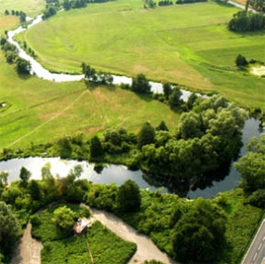

* Please note:
If a Home School child enters their school reward will go to a not-for-profit charity of their choice.
If a team enters with students from multiple schools the school award must be shared equally.

Student Action
Across the WORLD students are making their ideas a reality!
All students are encouraged to implement their ideas. Funding is available. Here are a few examples:

Riffle Crossings Cromer, Manitoba, Canada
Photograph Calendar Contest San Antonio de Areco, Argentina
Bat Boxes and Bird Houses Calgary, Alberta, Canada
Eco-Friendly Car Wash Solution Alexandria, Virginia, USA
Children’s Activity Book Ponoka, Alberta, Canada
Native Plant Pollinator Garden Antelope, California, USA
Rain barrels Saskatoon, Saskatchewan, Canada
Solar Panels on High School Camrose, Alberta, Canada

Thank YOU for participating in the program
A written proposal is required to enter the Caring for our Watersheds contest.
Student Workbooks do not qualify as a proposal.
Acknowledgements
This program is brought to you by Nutrien Ltd but would not be possible without the support from international community partners, volunteers, conservation groups, government and schools. Thank you to the following organizations for contributing to this workbook: Nutrien Ltd, Battle River Watershed Alliance, Center for Land-Based Learning, City of Calgary, Cows and Fish, Earth Force, Hamilton County Soil and Water Conservation District, Lower Trent Conservation, Oak Hammock Marsh Interpretive Centre, Partners for the Saskatchewan Watershed Alliance and Poudre Learning Center.

Enter your local contest at
www.CaringForOurWatersheds.com

